**Project Documentation:**

**Week 1 – Task 2:**

***Weather Application using API***

**Submitted By: Zara Khan**

**Submitted To: A&D Tech**

**Dated: 3st July, 2024**

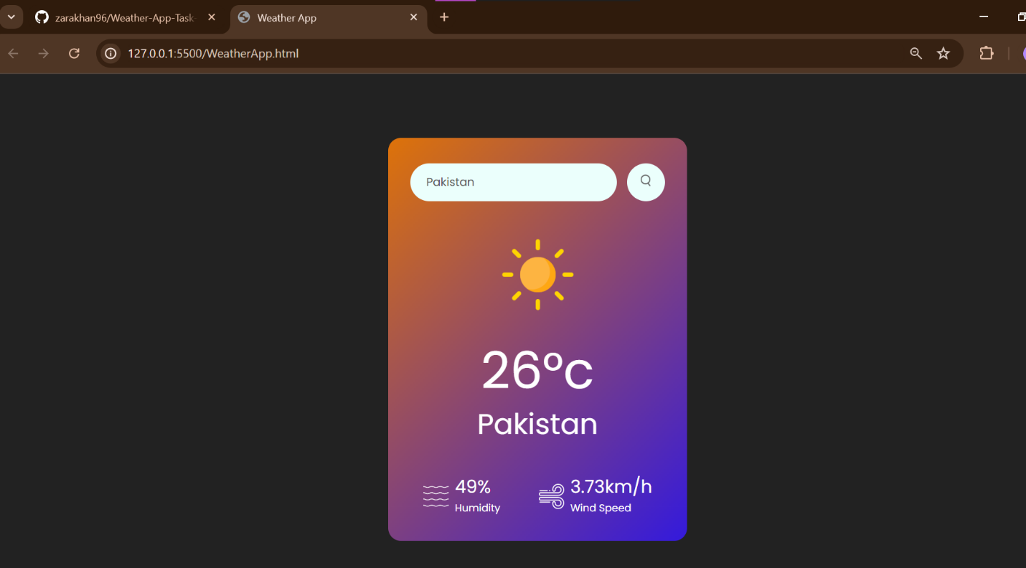



***Problem Statement***

Create a weather dashboard using HTML, CSS, and JavaScript that displays weather information fetched from a public API.

***Solution Overview***

I approached the project by watching YouTube tutorials because it was my first experience working with an API. It did took me time to understand the activation of the API keys and how to fetch it using JavaScript. The last project helped me with the CSS and Html properties and tags.

***Challenges and Resolutions***

* **Challenge: Hard JavaScript Functions**
* Some of the JavaScript functions were hard to understand.
* **Resolution:** Looked them up and tried to notice what happened if they aren’t being used.
* **Challenge: Working with API**
* Working with API for the first time was quite confusing, I didn’t know where to start from.
* **Resolution:** Watched a tutorial on how to operate the API and how it is used in the coding.

***Instructions***

**Setting Up the Project**

1. **Download the Project Files:**
   * Clone the repository from [GitHub link].
   * Alternatively, download the project zip file and extract it to your local machine.
2. **Open in Visual Studio Code (VS Code):**
   * Launch VS Code.
   * Open the entire project folder using File > Open Folder.

**Running the Project**

1. **Navigate to the Main Page:**
   * In the VS Code sidebar, locate and open WeatherApp.html.
2. **Testing Responsiveness:**
   * Use VS Code's built-in preview or open the website in different browsers and devices to ensure responsiveness.
3. **Running the App:**
   * Put in different country names and check the weather.